The World Affairs Council’s Global Competence Certificate Program was created to track students’ development of competencies that are critical to their success as global citizens who can contribute meaningfully to resolving global issues and ensuring a prosperous and equitable global economy. Upon successful completion of a website portfolio and presentation, eligible students will receive a Global Competence Certificate, issued by the World Affairs Council of Seattle. Students who present their portfolios in 9-11th grades will also have the opportunity to continue developing their portfolios, and to earn the certificate later in their high school careers.

You can use this Template to Create your Site
https://globalseattle.wixsite.com/globalcompetence/
- Go to ‘My Sites’
- Click ‘Template’
- Click ‘Duplicate’
- Add your content
- Preview and Publish your site!

Or create your own site with any of the readily available (free) tools for creating websites, such as Google Sites, WordPress, Weebly, or Wix. The example below uses the Wix Editor.
- Click ‘Start with Wix Editor’
- Select your template. The template category ‘blog’ is especially well-suited for this type of a website
- To add pages, select the ‘Home’ button at the top of the Wix site
- Add pages for the following 4 items:
  - About me
  - Global Learning
  - International Experiences and Engagement
  - Languages and Intercultural Experiences
- Delete any extra pages that came with your template
- Add content to each page by clicking the Plus (+) icon on the left sidebar. You can add text, images, videos, and other media.
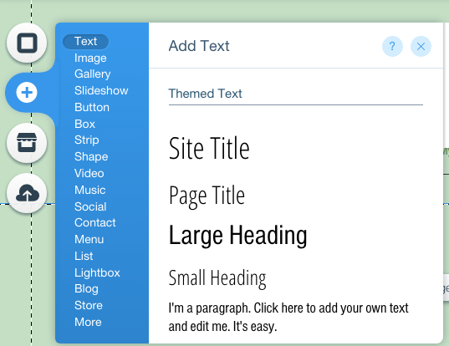 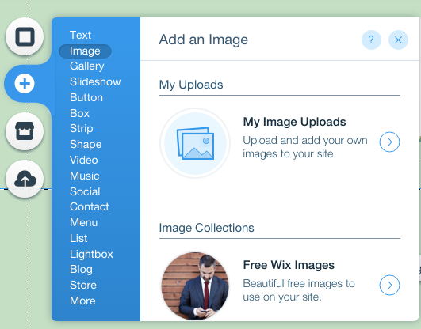

- Click the Eye icon at the top of the page to preview your site; this will show you how your site will look once it is published, and how others will navigate it.
- When you’re ready, publish your site!

Page 1: About Me
This will act as your homepage. Briefly (one paragraph) introduce yourself.
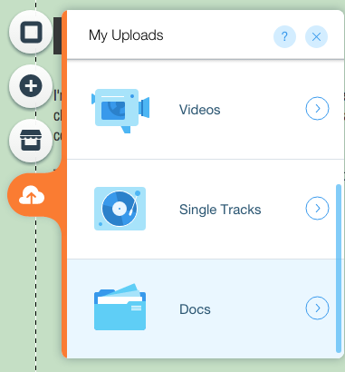
Upload a Resume and any other relevant documents that help to make your case for global competence. To upload your resume, click the Cloud icon (upload icon) and select ‘Docs’. Upload your resume and any other documents you would like to share on your site.
If you would like to do so, you may also upload an image of yourself or a picture that you feel represents you. You may use images from your computer, or browse through the images provided free from Wix.

Page 2: Global Learning Experiences
On this page, you should reflect on coursework or learning experiences over the course of their high school careers that challenged them to do each of the following:
- Investigate the World
- Recognize Perspectives
- Communicate Ideas
- Take Action.
To learn more about the four dimensions of global learning, visit:
https://globalseattle.wixsite.com/globalcompetence/global-learning-experiences

If you are struggling to identify unique academic experiences that fulfill each of these four dimensions for Global Learning, you may work with an advisor identify relevant coursework and learning experiences.
Write at least one paragraph for each dimension for Global Learning

Page 3: International Experiences and Engagement
On this page, you should reflect on one or two experiences where you have engaged with diverse cultures and communities. These reflections might be from traveling abroad- to study a language, do service work, or engage in international exchange. A student may also reflect on an international engagement experience here in Washington.
Write a 1-2 paragraph reflection.

Page 4: Languages and Intercultural Experiences
On this page, you should reflect on experiences around language learning and intercultural literacy.
Select two questions to respond to. Write a 1-2 paragraph response to two of the questions below:
- If you speak a language other than English at home or with friends or family members, describe that experience. What language(s) do you speak in your home and with your family? Do you use the language(s) outside the home? Have you been to a country where the language is spoken? How did it feel to speak the language there? Do you feel comfortable reading and writing the language too?
- Besides English, have you studied another language in school? If so which one(s)? In what grade did you start and now many years have you studied it (them)? How have you grown as a person by learning that language?
- If you’d like to learn other languages in the future, what would they be and why?
- Have you had an opportunity to test and qualify for the Seal of Biliteracy? (You could test with an AP or IB language test or World Language Credit testing for Competency-Based Credits.) Do you see bilingualism or multilingualism as an asset in our society? Why?

